**Sprint 2 - Accuracy Design Document**

**November 25 2020**

**Table of Contents**

[**1.** **EXECUTIVE SUMMARY 3**](https://docs.google.com/document/d/1uyXtX8Kw6pGrNfEGwMAvEg96NwEaVDwA/edit#heading=h.1fob9te)

[1.1 Project Overview 3](https://docs.google.com/document/d/1uyXtX8Kw6pGrNfEGwMAvEg96NwEaVDwA/edit#heading=h.1fob9te)

[1.2 Purpose and Scope of this Specification 3](https://docs.google.com/document/d/1uyXtX8Kw6pGrNfEGwMAvEg96NwEaVDwA/edit#heading=h.3znysh7)

[**2.** **PRODUCT/SERVICE DESCRIPTION 3**](https://docs.google.com/document/d/1uyXtX8Kw6pGrNfEGwMAvEg96NwEaVDwA/edit#heading=h.2et92p0)

[2.1 Product Context 3](https://docs.google.com/document/d/1uyXtX8Kw6pGrNfEGwMAvEg96NwEaVDwA/edit#heading=h.3as4poj)

[2.2 User Characteristics 3](https://docs.google.com/document/d/1uyXtX8Kw6pGrNfEGwMAvEg96NwEaVDwA/edit#heading=h.3dy6vkm)

[2.3 Assumptions 3](https://docs.google.com/document/d/1uyXtX8Kw6pGrNfEGwMAvEg96NwEaVDwA/edit#heading=h.1t3h5sf)

[2.4 Constraints 3](https://docs.google.com/document/d/1uyXtX8Kw6pGrNfEGwMAvEg96NwEaVDwA/edit#heading=h.4d34og8)

[2.5 Dependencies 4](https://docs.google.com/document/d/1uyXtX8Kw6pGrNfEGwMAvEg96NwEaVDwA/edit#heading=h.2s8eyo1)

[**3.** **REQUIREMENTS 4**](https://docs.google.com/document/d/1uyXtX8Kw6pGrNfEGwMAvEg96NwEaVDwA/edit#heading=h.17dp8vu)

[3.1 Functional Requirements 5](https://docs.google.com/document/d/1uyXtX8Kw6pGrNfEGwMAvEg96NwEaVDwA/edit#heading=h.1pxezwc)

[3.2 Security 5](https://docs.google.com/document/d/1uyXtX8Kw6pGrNfEGwMAvEg96NwEaVDwA/edit#heading=h.26in1rg)

[*3.2.1* *Protection 5*](https://docs.google.com/document/d/1uyXtX8Kw6pGrNfEGwMAvEg96NwEaVDwA/edit#heading=h.lnxbz9)

[*3.2.2* *Authorization and Authentication 6*](https://docs.google.com/document/d/1uyXtX8Kw6pGrNfEGwMAvEg96NwEaVDwA/edit#heading=h.35nkun2)

[3.3 Portability 6](https://docs.google.com/document/d/1uyXtX8Kw6pGrNfEGwMAvEg96NwEaVDwA/edit#heading=h.1ksv4uv)

[**4.** **REQUIREMENTS CONFIRMATION/STAKEHOLDER SIGN-OFF 6**](https://docs.google.com/document/d/1uyXtX8Kw6pGrNfEGwMAvEg96NwEaVDwA/edit#heading=h.49x2ik5)

[**5.** **SYSTEM DESIGN 6**](https://docs.google.com/document/d/1uyXtX8Kw6pGrNfEGwMAvEg96NwEaVDwA/edit#heading=h.z337ya)

[5.1 Algorithm 6](https://docs.google.com/document/d/1uyXtX8Kw6pGrNfEGwMAvEg96NwEaVDwA/edit#heading=h.3j2qqm3)

[5.2 System Flow 6](https://docs.google.com/document/d/1uyXtX8Kw6pGrNfEGwMAvEg96NwEaVDwA/edit#heading=h.1y810tw)

[5.3 Software 6](https://docs.google.com/document/d/1uyXtX8Kw6pGrNfEGwMAvEg96NwEaVDwA/edit#heading=h.4i7ojhp)

[5.4 Hardware 6](https://docs.google.com/document/d/1uyXtX8Kw6pGrNfEGwMAvEg96NwEaVDwA/edit#heading=h.2xcytpi)

[5.5 Test Plan 7](https://docs.google.com/document/d/1uyXtX8Kw6pGrNfEGwMAvEg96NwEaVDwA/edit#heading=h.1ci93xb)

[5.6 Task List/Gantt Chart 7](https://docs.google.com/document/d/1uyXtX8Kw6pGrNfEGwMAvEg96NwEaVDwA/edit#heading=h.3whwml4)

[5.7 Staffing Plan 7](https://docs.google.com/document/d/1uyXtX8Kw6pGrNfEGwMAvEg96NwEaVDwA/edit#heading=h.2bn6wsx)

1. Executive Summary
   1. ***Project Overview***

The purpose of this project is to move a robot in a figure eight pattern around a room. The target audience is beginners in programming. The user has complete control over the robot and where it goes and how it performs.

* 1. ***Purpose and Scope of this Specification***

Describe the purpose of this specification and its intended audience.   Include a description of what is within the scope and what is outside of the scope of  these specifications.  For example:

**In scope**

This document addresses requirements related to phase 2 of Project A:

* The intended audience is Monmouth University students in the computer science department.
* The robot must complete a certain course in a specific manner.

**Out of Scope**

The following items in phase 3 of Project A are out of scope:

* Robot completing the third course.

1. Product/Service Description

In this section, describe the general factors that affect the product and its requirements. This section should contain background information, not state specific requirements (provide the reasons why certain specific requirements are later specified).

* 1. ***Product Context***

How does this product relate to other products? Is it independent and self-contained?  Does it interface with a variety of related systems?  Describe these relationships or use a diagram to show the major components of the larger system, interconnections, and external interfaces.

* 1. ***User Characteristics***

Create general customer profiles for each type of user who will be using the product. Profiles should include:

* Students in computer science majors
* Students learning block coding
* some basic technical expertise
* Need some basic knowledge to create program
  1. ***Assumptions***
* The Operation system is free and easy to download on any device.
* The equipment is available at many retail stores
* If the operating system is not able to download then the robot will not work.
* The expertise required is very little for the reason that the Operating system is very user friendly.
  1. ***Constraints***

Describe any items that will constrain the design options, including

* Room was unavailable
* Floor was uneven
* group was unable to meet because of conflicts
* measurements had to be reduced to fit in the area available
  1. ***Dependencies***
* The robot’s aim must be adjusted every time it disconnects from the app
* The space where testing took place

1. Requirements

|  |  |  |  |  |  |
| --- | --- | --- | --- | --- | --- |
| **Req#** | **Requirement** | **Comments** | **Priority** | **Date Rvwd** | **SME Reviewed / Approved** |
| ACCURA_01 | The robot must run the figure 8 course 5 times | Must be consistent | 1 | 11/25 | Devin |
| ACCURA_02 | Robot must stay on the path | Can veer of slightly | 2 | 11/25 | Devin |
| ACCURA_03 | After the robot finishes the course must say “I am the winner” | Voice must be clear and it must be spoken at the proper time | 4 | 11/25 | Devin |
| ACCURA_04 | After the robot speaks it must flash multi color leds. | LEDs must  turn on a the proper time | 3 | 11/25 | Devin |

* 1. ***Security***
* encryption
* activity logging, historical data sets
* restrictions on intermodule communications
* data integrity checks
* app is password protected so not anyone can edit the program
  + 1. **Authorization and Authentication**

Specify the Authorization and Authentication factors. Consider using standard tools such as PubCookie.

* 1. ***Portability***

If portability is a requirement, specify attributes of the system that relate to the ease of porting the system to other host machines and/or operating systems. For example,

* Percentage of components with host-dependent code; 100% dependant
* Percentage of code that is host dependent; 100%
* Use of a proven portable language; Block code
* Use of a particular operating system; Sphero App
* The need for environment-independence - the product must operate the same regardless of  operating systems, networks, development or production environments.

1. Requirements Confirmation/Stakeholder sign-off

Include documentation of the approval or confirmation of the requirements here.  For example:

|  |  |  |
| --- | --- | --- |
| **Meeting Date** | **Attendees (name and role)** | **Comments** |
| 11/23/20 | Jack Berkowitz, John Cheema, Devin Brattvet | confirmed all |
| MM/DD/YY | My group member names | confirmed…………. |

1. System Design

This section will provide all details concerning the technical design, staffing, coding, and testing the system

* 1. ***Algorithm***

startTile = 0

robot = figure8()

for robot in range(0,4):

    figure8()

robot = startTile

speak(“I am a winner!”)

multicolorLight = True

* figure8() is an action of the robot doing a figure 8.
* speak is used as the robot speaking
  1. ***System Flow***

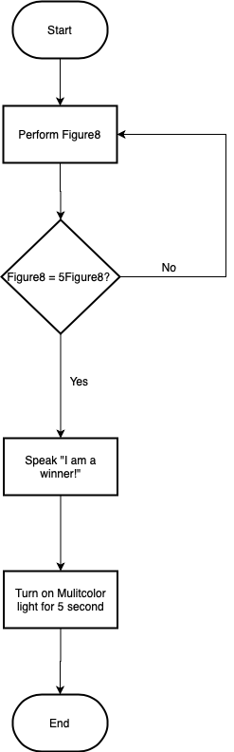

* 1. ***Software***

The software that we used is the Sphero app. This app also houses the OS for the robot. We used block coding to program the robot.

* 1. ***Hardware***

The hardware was the Sphero EDU:SPRK + STEM robot

* 1. ***Test Plan***

Include a test plan showing all unit tests performed for this application, Include test rational, test date, staff member, pass/fail status

|  |  |  |  |  |  |
| --- | --- | --- | --- | --- | --- |
| **Reason for Test Case** | **Test Date** | **Expected Output** | **Observed Output** | **Staff Name** | **Pass/Fail** |
| To see if robot will stay in the first half of the loop | 11/19/2020 | The robot will stay on course than make a stop | The robot stayed on course but failed to stay in the loop | jack | fail |
| To see if the robot will stay on course | 11/19/2020 | The robot will stay on its path for the first loop then stop in the middle | The robot stayed on course for the first half of the loop. Then it went off course into a wall. | jack | fail |
| To see if the robot will make the first loop of the figure 8. | 11/19/2020 | The robot will make the first loop then stop in the middle | The robot made the loop and stopped in the middle | Jack | pass |
| To see if the robot will make the first loop for the figure 8 and cross over to the next loop | 11/19/2020 | The robot will make the first loop but will fail to stay on the second loop Of the figure 8. | The robot makes the first loop, When the robot drives over to the second loop, it drives into the wall again. | Jack | fail |
| To see if the robot completes the figure 8. | 11/19/2020 | The robot will complete the figure 8 and stop in the middle | The robot completed the figure 8 and stopped at the start point | jack | pass |
| To add a loop and to see if the robot will stay on course repeatedly. | 11/19/2020 | The robot will loop the figure 8 five times and stop at the end point. | The robot stayed on path and repeated the path five times | jack | pass |
| To see if the colors will flash at the end | 11/19/2020 | The colors will flash and change | the colors stayed the same | jack | fail |
| to see if the colors changed | 11/20/2020 | The colors will change and flash | The colors changed and flashed | Jack | pass |
| Add a speaking voice that says “ I am the winner” | 11/20/2020 | The robot will speak at the end of the program | The robot spoke at the end of the program | Jack | pass |
| to run to program several times to see if any issue develops | 11/21/2020 | The robot will complete the course and light up and speak at the right times | The robot completed the course without issue | Jack | pass |

* 1. ***Task List/Gantt Chart***

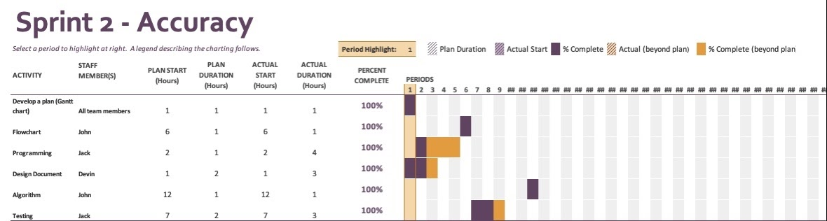

* 1. ***Staffing Plan***

Insert a chart/table that depicts the roles and responsibilities of each team member that worked on this project

|  |  |  |  |
| --- | --- | --- | --- |
| Name | Role | Responsibility | Reports To |
| Jack Berkowitz | Programmer and Tester | Programs that robot and tests code. | John |
| John Chemma | Organizer and Planner | Makes sure everyone is on the right tracks and create foundations to build upon the code | Devin |
| Devin Brattvet | Project Manager | Ghantt chart and functional requirements | Jack |